ML LAB 1:  
Date:05-04-2024  
  
  
**1. Write a python program to import and export data using Pandas library functions**

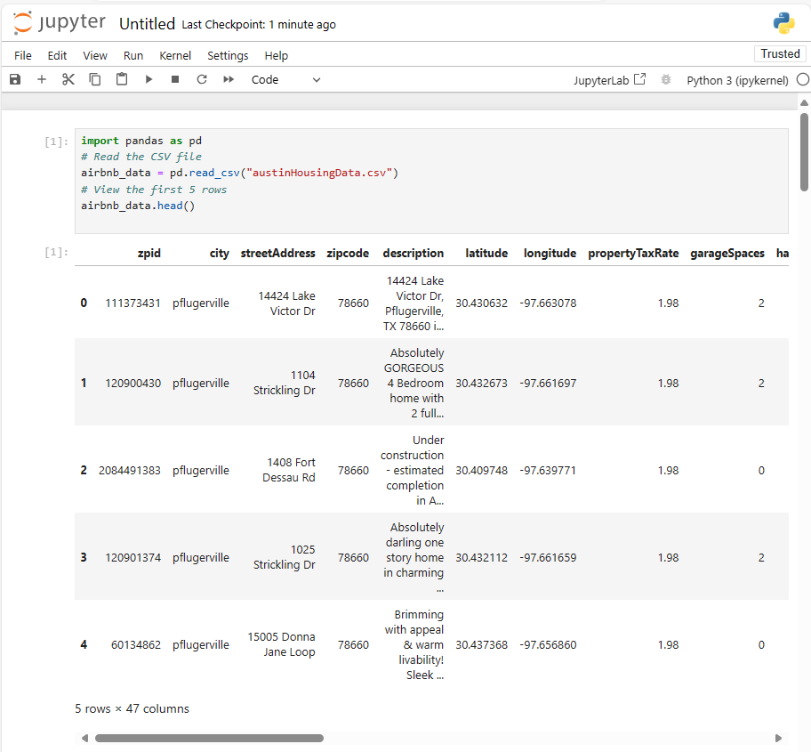

**End-to-End Machine Learning Project :**

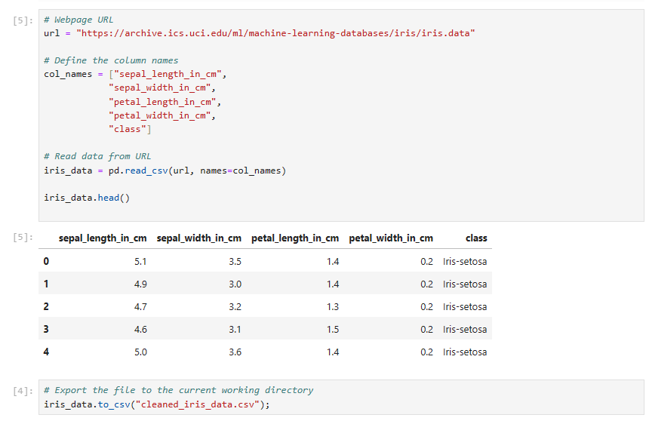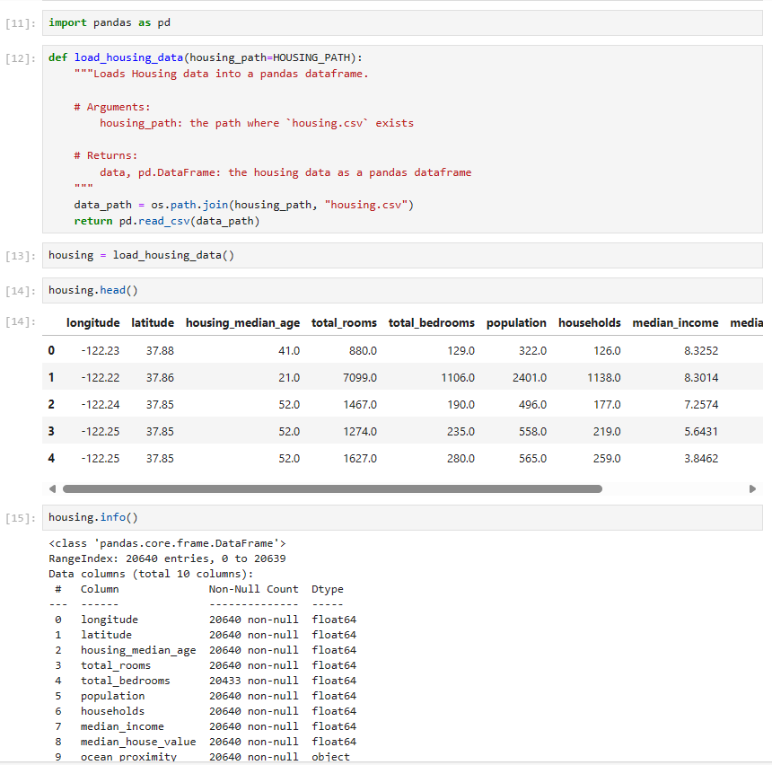

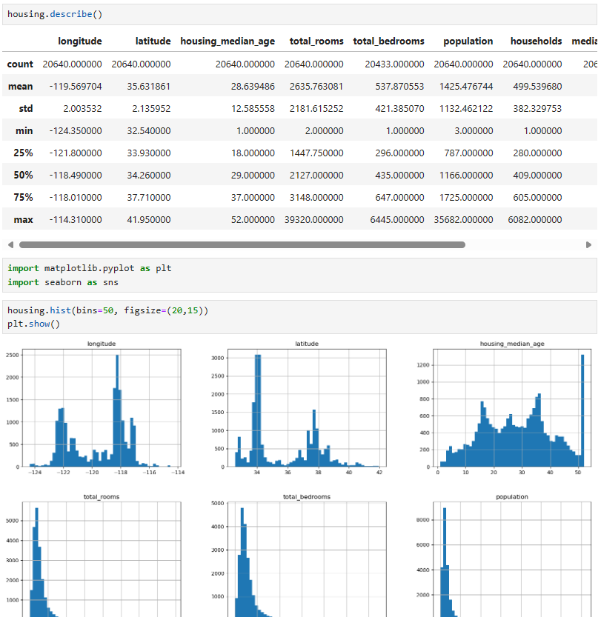

**4. stratified sampling**.

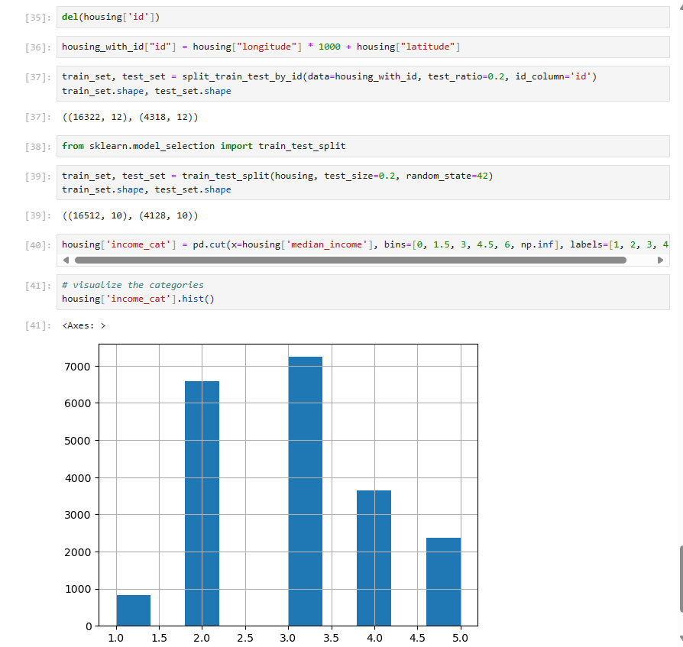

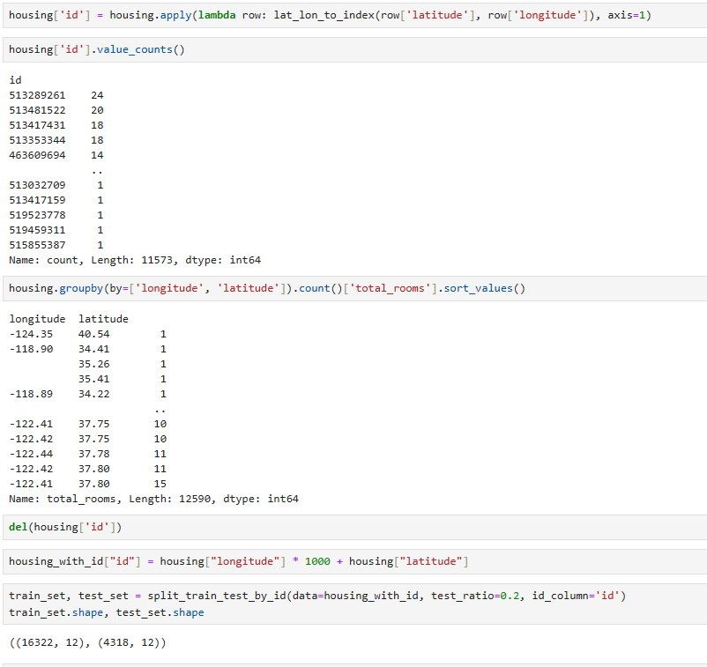

**3.Discover & Visualize the Data to Gain Insights”:**

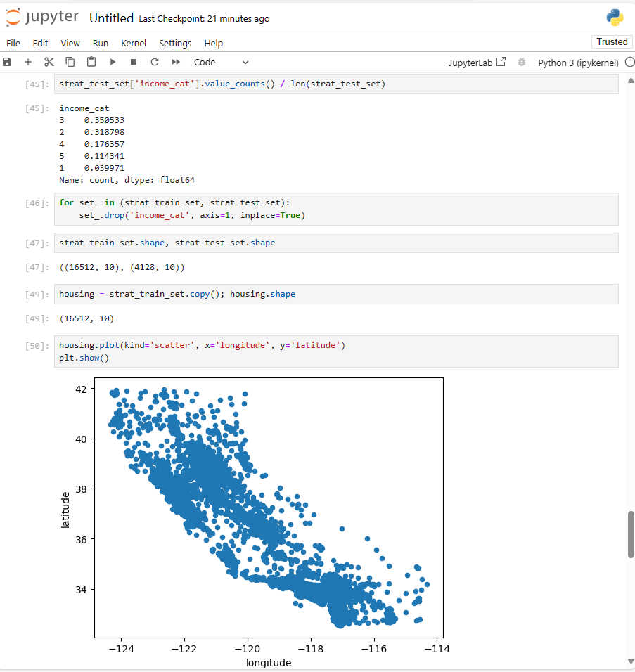

**Visualizing Geographical Data:**

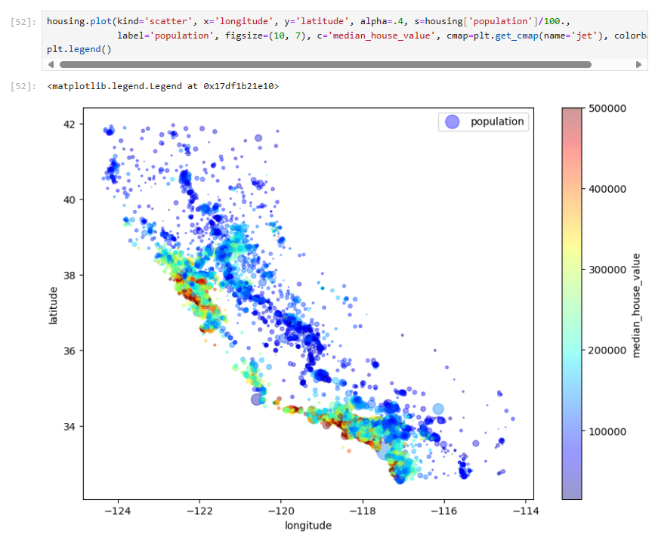

Write a python program to import and export data using Pandas library function